Distributions of PIA variables

Populism
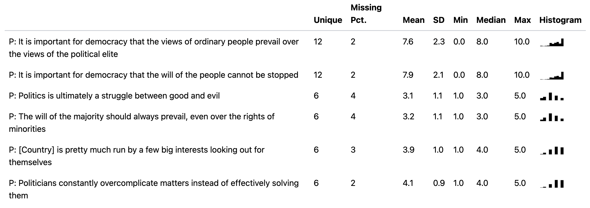

Illiberalism
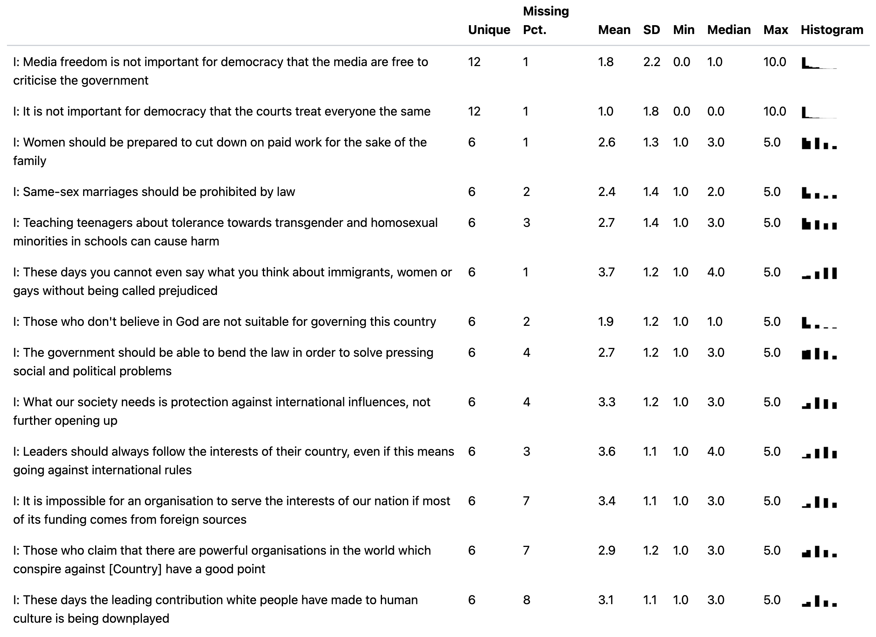

Authoritarianism